EXPERIMENT NO 2.2

Aim
To design and implement a dynamic product filtering system using JavaScript DOM manipulation, where users can select categories from a dropdown menu, and the displayed products update in real-time without reloading the page.

Theory
Filtering is a common feature in modern web applications, especially in e-commerce platforms where users need to quickly find products based on categories such as electronics, fashion, books, or price ranges.
- DOM Manipulation: JavaScript allows dynamic modification of HTML elements through the Document Object Model (DOM).
- Event Handling: The change event of a dropdown (<select>) can be used to trigger filtering actions.
- Attributes for Categorization: Products are assigned a custom attribute (data-category) to group them into categories.
- Dynamic Display: By controlling the style.display property, products are shown or hidden depending on the selected category.
This approach ensures interactive filtering without requiring a page reload, improving user experience and application responsiveness.

Code Implementation
<!DOCTYPE html>
<html lang="en">
<head>
<meta charset="UTF-8">
<meta name="viewport" content="width=device-width, initial-scale=1.0">
<title>Dynamic Product Filter</title>
<style>
body { font-family: Arial, sans-serif; padding: 20px; }
.product {
border: 1px solid #ccc;
padding: 10px;
margin: 5px;
border-radius: 8px;
display: inline-block;
width: 150px;
text-align: center;
}
#products { margin-top: 20px; }
</style>
</head>
<body>

<h2>Product List</h2>

<!-- Dropdown for filtering -->
<label for="filter">Filter by Category:</label>
<select id="filter">
<option value="all">All</option>
<option value="electronics">Electronics</option>
<option value="fashion">Fashion</option>
<option value="books">Books</option>
</select>

<!-- Products container -->
<div id="products">
<div class="product" data-category="electronics">Laptop</div>
<div class="product" data-category="electronics">Smartphone</div>
<div class="product" data-category="fashion">T-shirt</div>
<div class="product" data-category="fashion">Shoes</div>
<div class="product" data-category="books">Novel</div>
<div class="product" data-category="books">Comics</div>
</div>

<script>
const filterDropdown = document.getElementById("filter");
const products = document.querySelectorAll(".product");

// Event Listener for dropdown
filterDropdown.addEventListener("change", function() {
const selected = this.value;

products.forEach(product => {
if (selected === "all" || product.getAttribute("data-category") === selected) {
product.style.display = "inline-block"; // show product
} else {
product.style.display = "none"; // hide product
}
});
});
</script>

</body>
</html>

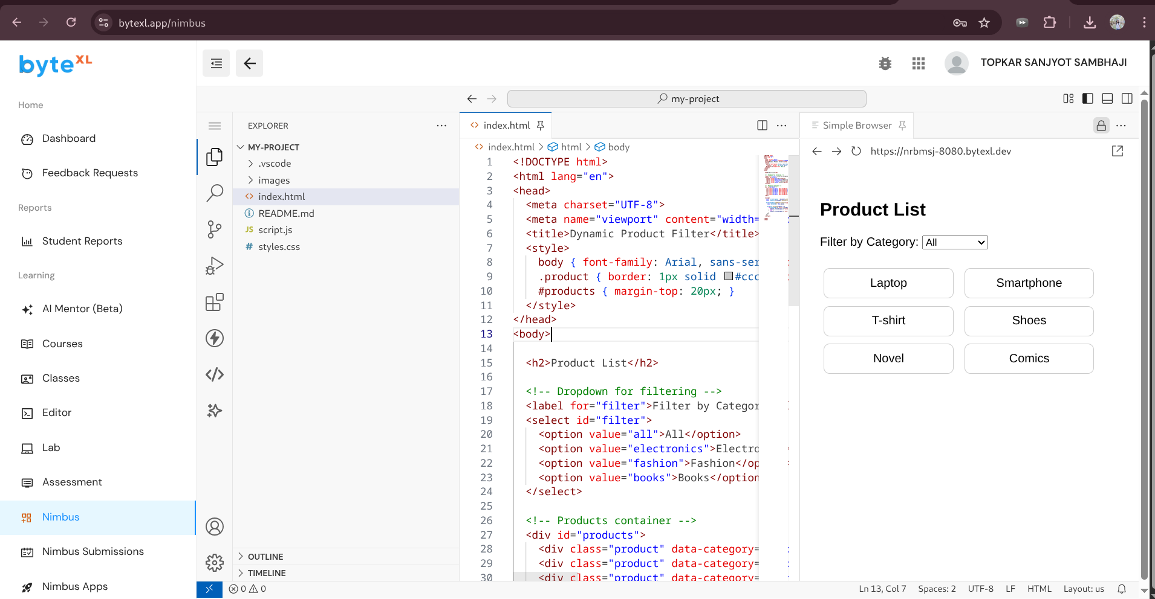

Learning Outcomes
After completing this experiment, the student will be able to:
- Understand the concept of DOM manipulation using JavaScript.
- Implement event-driven programming using the change event on dropdowns.
- Use custom HTML attributes (data-*) for categorizing and filtering elements.
- Dynamically control the visibility of HTML elements using JavaScript.
- Apply this knowledge to real-world applications such as e-commerce product filtering, search dashboards, and data categorization tools.

